**LAPORAN PRAKTIKUM**

**BASIS DATA**



**DISUSUN OLEH**

**ILHAM NUR ROMDONI M0520038**

**PROGRAM INFORMATIKA**

**FAKULTAS MIPA**

**UNIVERSITAS SEBELAS MARET**

**2021**

**Diagram**

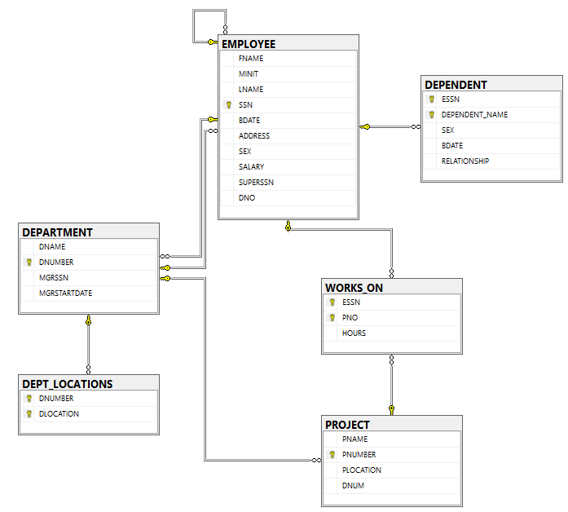

**Data per Tabel (show top 1000)**

**EMPLOYEE**

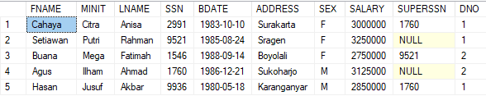

**DEPARTMENT DEPT_LOCATIONS**

** **

**PROJECT WORKS_ON**

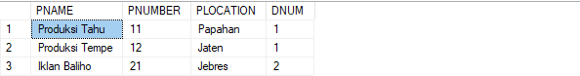 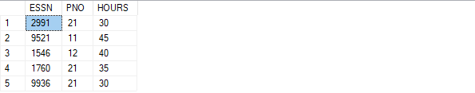

**DEPENDENT**



**Kode SQL**

USE [master]

GO

/****** Object: Database [COMPANY] Script Date: 22/10/2021 18:24:43 ******/

CREATE DATABASE [COMPANY]

CONTAINMENT = NONE

ON PRIMARY

( NAME = N'COMPANY', FILENAME = N'C:\Program Files\Microsoft SQL Server\MSSQL15.MSSQLSERVER\MSSQL\DATA\COMPANY.mdf' , SIZE = 8192KB , MAXSIZE = UNLIMITED, FILEGROWTH = 65536KB )

LOG ON

( NAME = N'COMPANY_log', FILENAME = N'C:\Program Files\Microsoft SQL Server\MSSQL15.MSSQLSERVER\MSSQL\DATA\COMPANY_log.ldf' , SIZE = 8192KB , MAXSIZE = 2048GB , FILEGROWTH = 65536KB )

WITH CATALOG_COLLATION = DATABASE_DEFAULT

GO

ALTER DATABASE [COMPANY] SET COMPATIBILITY_LEVEL = 150

GO

IF (1 = FULLTEXTSERVICEPROPERTY('IsFullTextInstalled'))

begin

EXEC [COMPANY].[dbo].[sp_fulltext_database] @action = 'enable'

end

GO

ALTER DATABASE [COMPANY] SET ANSI_NULL_DEFAULT OFF

GO

ALTER DATABASE [COMPANY] SET ANSI_NULLS OFF

GO

ALTER DATABASE [COMPANY] SET ANSI_PADDING OFF

GO

ALTER DATABASE [COMPANY] SET ANSI_WARNINGS OFF

GO

ALTER DATABASE [COMPANY] SET ARITHABORT OFF

GO

ALTER DATABASE [COMPANY] SET AUTO_CLOSE OFF

GO

ALTER DATABASE [COMPANY] SET AUTO_SHRINK OFF

GO

ALTER DATABASE [COMPANY] SET AUTO_UPDATE_STATISTICS ON

GO

ALTER DATABASE [COMPANY] SET CURSOR_CLOSE_ON_COMMIT OFF

GO

ALTER DATABASE [COMPANY] SET CURSOR_DEFAULT GLOBAL

GO

ALTER DATABASE [COMPANY] SET CONCAT_NULL_YIELDS_NULL OFF

GO

ALTER DATABASE [COMPANY] SET NUMERIC_ROUNDABORT OFF

GO

ALTER DATABASE [COMPANY] SET QUOTED_IDENTIFIER OFF

GO

ALTER DATABASE [COMPANY] SET RECURSIVE_TRIGGERS OFF

GO

ALTER DATABASE [COMPANY] SET DISABLE_BROKER

GO

ALTER DATABASE [COMPANY] SET AUTO_UPDATE_STATISTICS_ASYNC OFF

GO

ALTER DATABASE [COMPANY] SET DATE_CORRELATION_OPTIMIZATION OFF

GO

ALTER DATABASE [COMPANY] SET TRUSTWORTHY OFF

GO

ALTER DATABASE [COMPANY] SET ALLOW_SNAPSHOT_ISOLATION OFF

GO

ALTER DATABASE [COMPANY] SET PARAMETERIZATION SIMPLE

GO

ALTER DATABASE [COMPANY] SET READ_COMMITTED_SNAPSHOT OFF

GO

ALTER DATABASE [COMPANY] SET HONOR_BROKER_PRIORITY OFF

GO

ALTER DATABASE [COMPANY] SET RECOVERY FULL

GO

ALTER DATABASE [COMPANY] SET MULTI_USER

GO

ALTER DATABASE [COMPANY] SET PAGE_VERIFY CHECKSUM

GO

ALTER DATABASE [COMPANY] SET DB_CHAINING OFF

GO

ALTER DATABASE [COMPANY] SET FILESTREAM( NON_TRANSACTED_ACCESS = OFF )

GO

ALTER DATABASE [COMPANY] SET TARGET_RECOVERY_TIME = 60 SECONDS

GO

ALTER DATABASE [COMPANY] SET DELAYED_DURABILITY = DISABLED

GO

ALTER DATABASE [COMPANY] SET ACCELERATED_DATABASE_RECOVERY = OFF

GO

EXEC sys.sp_db_vardecimal_storage_format N'COMPANY', N'ON'

GO

ALTER DATABASE [COMPANY] SET QUERY_STORE = OFF

GO

USE [COMPANY]

GO

/****** Object: Table [dbo].[DEPARTMENT] Script Date: 22/10/2021 18:24:43 ******/

SET ANSI_NULLS ON

GO

SET QUOTED_IDENTIFIER ON

GO

CREATE TABLE [dbo].[DEPARTMENT](

[DNAME] [nvarchar](50) NOT NULL,

[DNUMBER] [bigint] NOT NULL,

[MGRSSN] [smallint] NOT NULL,

[MGRSTARTDATE] [date] NOT NULL,

CONSTRAINT [PK_DEPARTMENT_1] PRIMARY KEY CLUSTERED

(

[DNUMBER] ASC

)WITH (PAD_INDEX = OFF, STATISTICS_NORECOMPUTE = OFF, IGNORE_DUP_KEY = OFF, ALLOW_ROW_LOCKS = ON, ALLOW_PAGE_LOCKS = ON, OPTIMIZE_FOR_SEQUENTIAL_KEY = OFF) ON [PRIMARY]

) ON [PRIMARY]

GO

/****** Object: Table [dbo].[DEPENDENT] Script Date: 22/10/2021 18:24:43 ******/

SET ANSI_NULLS ON

GO

SET QUOTED_IDENTIFIER ON

GO

CREATE TABLE [dbo].[DEPENDENT](

[ESSN] [smallint] NOT NULL,

[DEPENDENT_NAME] [nvarchar](50) NOT NULL,

[SEX] [char](1) NOT NULL,

[BDATE] [date] NOT NULL,

[RELATIONSHIP] [nvarchar](50) NOT NULL,

CONSTRAINT [PK_DEPENDENT_1] PRIMARY KEY CLUSTERED

(

[ESSN] ASC,

[DEPENDENT_NAME] ASC

)WITH (PAD_INDEX = OFF, STATISTICS_NORECOMPUTE = OFF, IGNORE_DUP_KEY = OFF, ALLOW_ROW_LOCKS = ON, ALLOW_PAGE_LOCKS = ON, OPTIMIZE_FOR_SEQUENTIAL_KEY = OFF) ON [PRIMARY]

) ON [PRIMARY]

GO

/****** Object: Table [dbo].[DEPT_LOCATIONS] Script Date: 22/10/2021 18:24:43 ******/

SET ANSI_NULLS ON

GO

SET QUOTED_IDENTIFIER ON

GO

CREATE TABLE [dbo].[DEPT_LOCATIONS](

[DNUMBER] [bigint] NOT NULL,

[DLOCATION] [nvarchar](50) NOT NULL,

CONSTRAINT [PK_DEPT_LOCATIONS] PRIMARY KEY CLUSTERED

(

[DNUMBER] ASC,

[DLOCATION] ASC

)WITH (PAD_INDEX = OFF, STATISTICS_NORECOMPUTE = OFF, IGNORE_DUP_KEY = OFF, ALLOW_ROW_LOCKS = ON, ALLOW_PAGE_LOCKS = ON, OPTIMIZE_FOR_SEQUENTIAL_KEY = OFF) ON [PRIMARY]

) ON [PRIMARY]

GO

/****** Object: Table [dbo].[EMPLOYEE] Script Date: 22/10/2021 18:24:43 ******/

SET ANSI_NULLS ON

GO

SET QUOTED_IDENTIFIER ON

GO

CREATE TABLE [dbo].[EMPLOYEE](

[FNAME] [nvarchar](50) NOT NULL,

[MINIT] [nvarchar](50) NOT NULL,

[LNAME] [nvarchar](50) NOT NULL,

[SSN] [smallint] NOT NULL,

[BDATE] [date] NOT NULL,

[ADDRESS] [text] NOT NULL,

[SEX] [char](1) NOT NULL,

[SALARY] [int] NOT NULL,

[SUPERSSN] [smallint] NULL,

[DNO] [bigint] NOT NULL,

CONSTRAINT [PK_EMPLOYEE] PRIMARY KEY CLUSTERED

(

[SSN] ASC

)WITH (PAD_INDEX = OFF, STATISTICS_NORECOMPUTE = OFF, IGNORE_DUP_KEY = OFF, ALLOW_ROW_LOCKS = ON, ALLOW_PAGE_LOCKS = ON, OPTIMIZE_FOR_SEQUENTIAL_KEY = OFF) ON [PRIMARY]

) ON [PRIMARY] TEXTIMAGE_ON [PRIMARY]

GO

/****** Object: Table [dbo].[PROJECT] Script Date: 22/10/2021 18:24:43 ******/

SET ANSI_NULLS ON

GO

SET QUOTED_IDENTIFIER ON

GO

CREATE TABLE [dbo].[PROJECT](

[PNAME] [nvarchar](50) NOT NULL,

[PNUMBER] [bigint] NOT NULL,

[PLOCATION] [nvarchar](50) NOT NULL,

[DNUM] [bigint] NOT NULL,

CONSTRAINT [PK_PROJECT_1] PRIMARY KEY CLUSTERED

(

[PNUMBER] ASC

)WITH (PAD_INDEX = OFF, STATISTICS_NORECOMPUTE = OFF, IGNORE_DUP_KEY = OFF, ALLOW_ROW_LOCKS = ON, ALLOW_PAGE_LOCKS = ON, OPTIMIZE_FOR_SEQUENTIAL_KEY = OFF) ON [PRIMARY]

) ON [PRIMARY]

GO

/****** Object: Table [dbo].[WORKS_ON] Script Date: 22/10/2021 18:24:43 ******/

SET ANSI_NULLS ON

GO

SET QUOTED_IDENTIFIER ON

GO

CREATE TABLE [dbo].[WORKS_ON](

[ESSN] [smallint] NOT NULL,

[PNO] [bigint] NOT NULL,

[HOURS] [smallint] NOT NULL,

CONSTRAINT [PK_WORKS_ON] PRIMARY KEY CLUSTERED

(

[ESSN] ASC,

[PNO] ASC

)WITH (PAD_INDEX = OFF, STATISTICS_NORECOMPUTE = OFF, IGNORE_DUP_KEY = OFF, ALLOW_ROW_LOCKS = ON, ALLOW_PAGE_LOCKS = ON, OPTIMIZE_FOR_SEQUENTIAL_KEY = OFF) ON [PRIMARY]

) ON [PRIMARY]

GO

ALTER TABLE [dbo].[DEPARTMENT] WITH CHECK ADD CONSTRAINT [FK_EMPLOYEE_DEPARTMENT] FOREIGN KEY([MGRSSN])

REFERENCES [dbo].[EMPLOYEE] ([SSN])

GO

ALTER TABLE [dbo].[DEPARTMENT] CHECK CONSTRAINT [FK_EMPLOYEE_DEPARTMENT]

GO

ALTER TABLE [dbo].[DEPENDENT] WITH CHECK ADD CONSTRAINT [FK_EMPLOYEE_DEPENDENT] FOREIGN KEY([ESSN])

REFERENCES [dbo].[EMPLOYEE] ([SSN])

GO

ALTER TABLE [dbo].[DEPENDENT] CHECK CONSTRAINT [FK_EMPLOYEE_DEPENDENT]

GO

ALTER TABLE [dbo].[DEPT_LOCATIONS] WITH CHECK ADD CONSTRAINT [FK_DEPARTMENT_DEPT_LOCATIONS] FOREIGN KEY([DNUMBER])

REFERENCES [dbo].[DEPARTMENT] ([DNUMBER])

GO

ALTER TABLE [dbo].[DEPT_LOCATIONS] CHECK CONSTRAINT [FK_DEPARTMENT_DEPT_LOCATIONS]

GO

ALTER TABLE [dbo].[EMPLOYEE] WITH CHECK ADD CONSTRAINT [FK_DEPARTMENT_EMPLOYEE] FOREIGN KEY([DNO])

REFERENCES [dbo].[DEPARTMENT] ([DNUMBER])

GO

ALTER TABLE [dbo].[EMPLOYEE] CHECK CONSTRAINT [FK_DEPARTMENT_EMPLOYEE]

GO

ALTER TABLE [dbo].[EMPLOYEE] WITH CHECK ADD CONSTRAINT [FK_EMPLOYEE_EMPLOYEE] FOREIGN KEY([SUPERSSN])

REFERENCES [dbo].[EMPLOYEE] ([SSN])

GO

ALTER TABLE [dbo].[EMPLOYEE] CHECK CONSTRAINT [FK_EMPLOYEE_EMPLOYEE]

GO

ALTER TABLE [dbo].[PROJECT] WITH CHECK ADD CONSTRAINT [FK_DEPARTMENT_PROJECT] FOREIGN KEY([DNUM])

REFERENCES [dbo].[DEPARTMENT] ([DNUMBER])

GO

ALTER TABLE [dbo].[PROJECT] CHECK CONSTRAINT [FK_DEPARTMENT_PROJECT]

GO

ALTER TABLE [dbo].[WORKS_ON] WITH CHECK ADD CONSTRAINT [FK_EMPLOYEE_WORKS_ON] FOREIGN KEY([ESSN])

REFERENCES [dbo].[EMPLOYEE] ([SSN])

GO

ALTER TABLE [dbo].[WORKS_ON] CHECK CONSTRAINT [FK_EMPLOYEE_WORKS_ON]

GO

ALTER TABLE [dbo].[WORKS_ON] WITH CHECK ADD CONSTRAINT [FK_PROJECT_WORKS_ON] FOREIGN KEY([PNO])

REFERENCES [dbo].[PROJECT] ([PNUMBER])

GO

ALTER TABLE [dbo].[WORKS_ON] CHECK CONSTRAINT [FK_PROJECT_WORKS_ON]

GO

USE [master]

GO

ALTER DATABASE [COMPANY] SET READ_WRITE

GO